-----------------------------------------------------------------------------------------------

**Create a S3 bucket, with no public access and upload files to the bucket & view the logs for the uploaded files. Launch two ec2-instances and connect it to a application load balancer, where the output traffic from the server must be an load balancer IP address**

**> Create a S3 bucket, with no public access**

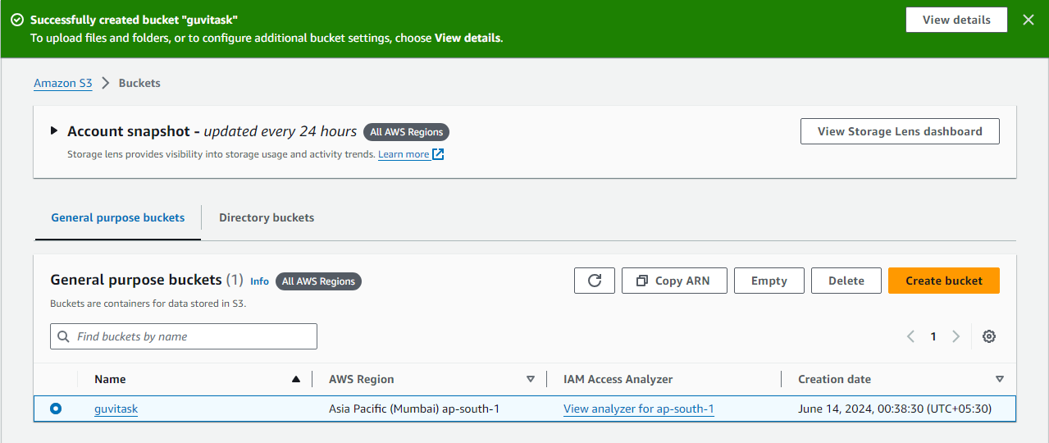

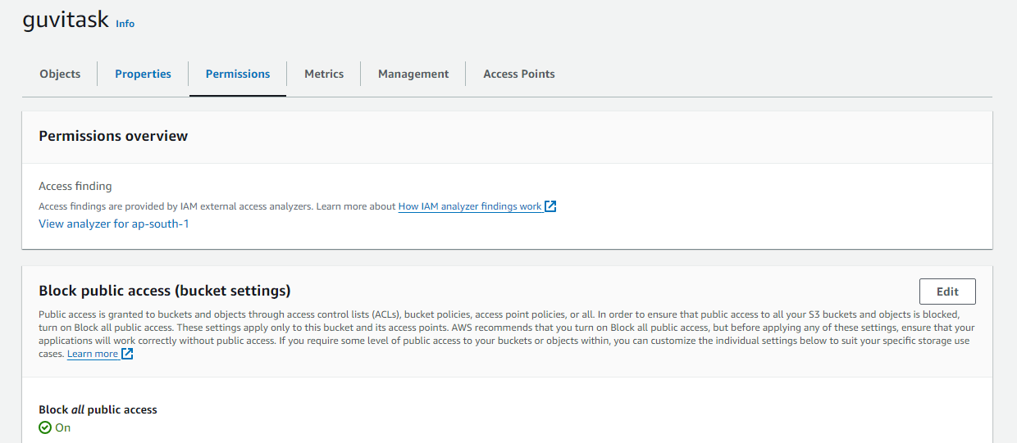

Logs enabled

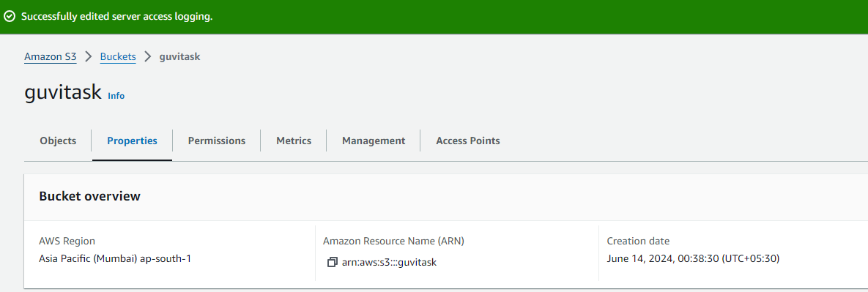

> **upload files to the bucket & view the logs for the uploaded files**

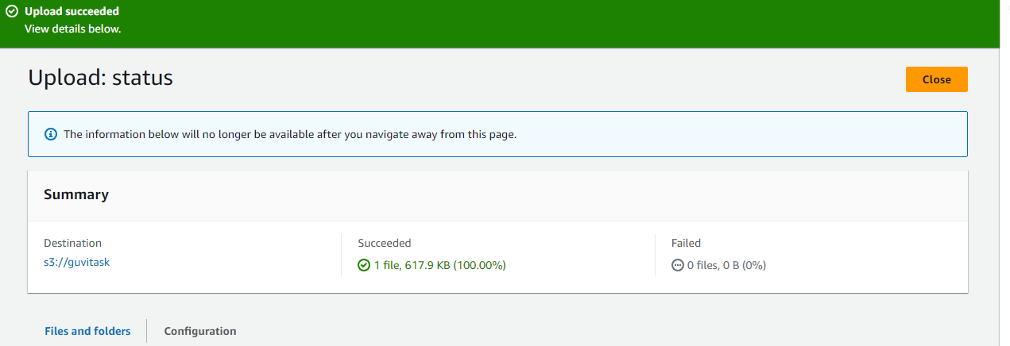

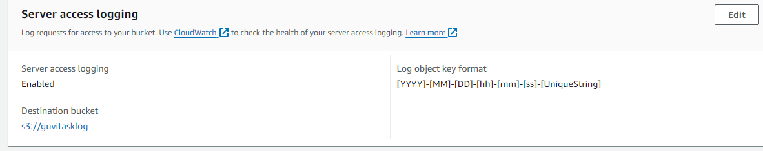

Log enabled

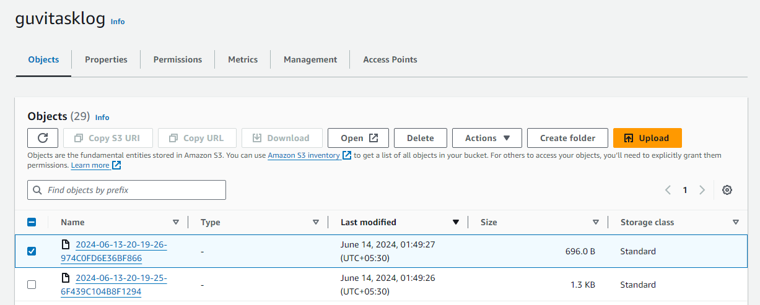

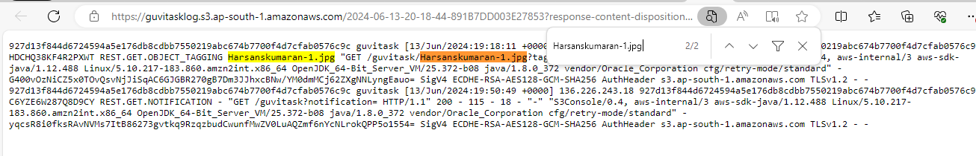

> **Launch two ec2-instances and connect it to a application load balancer, where the output traffic from the server must be an load balancer IP address**

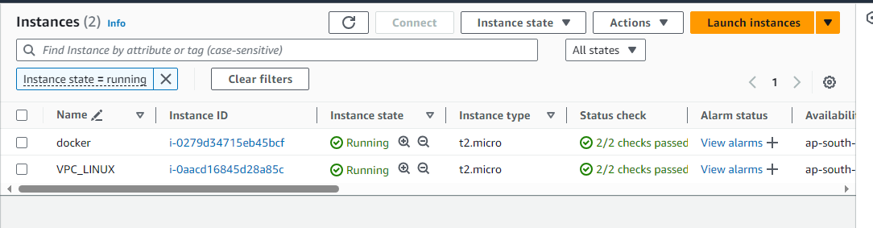

Launched 2 ec2 instance and installed web server respectively

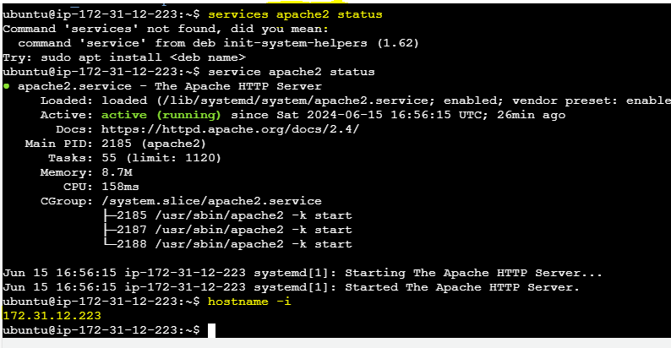

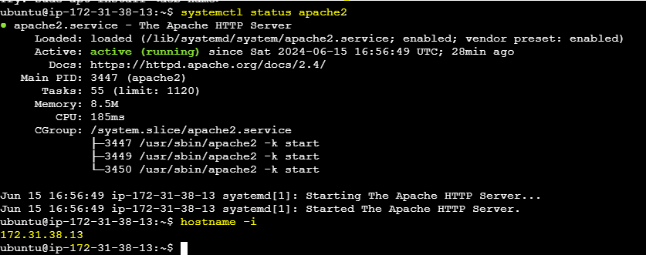

Created target group (TG)

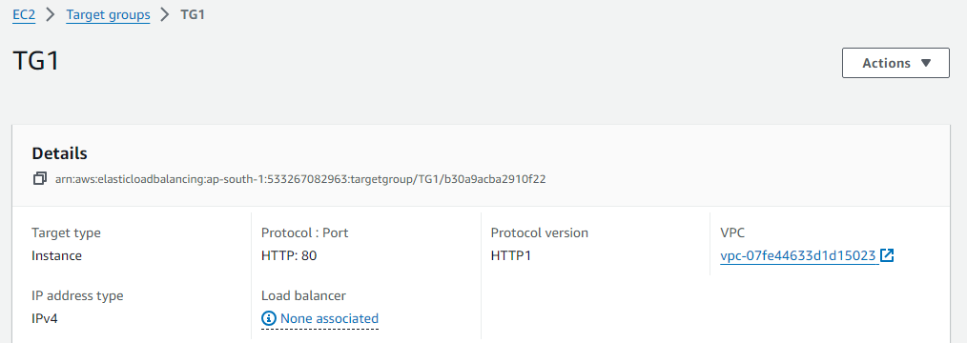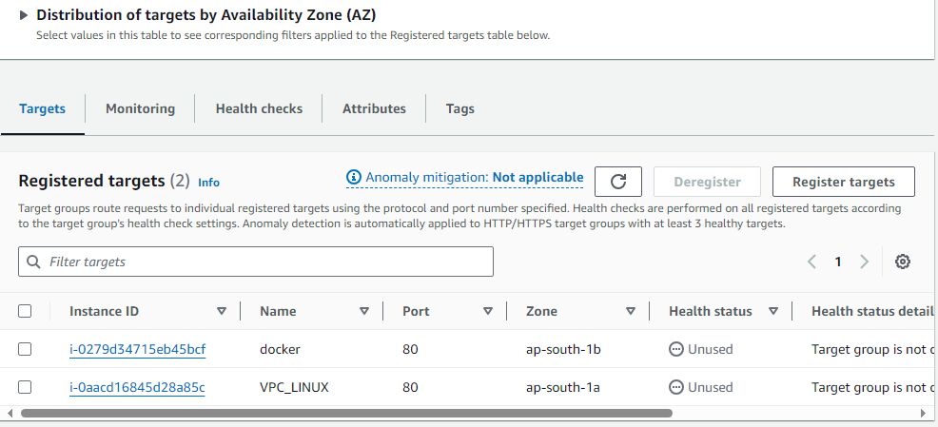

Created LB and mapped TG

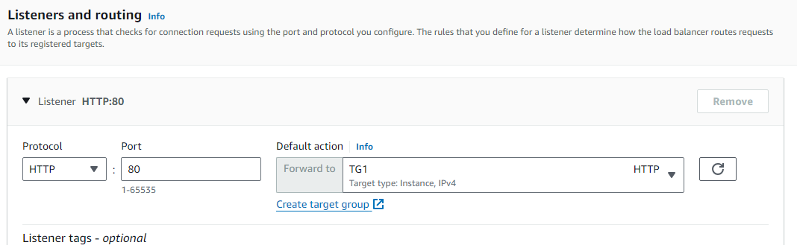

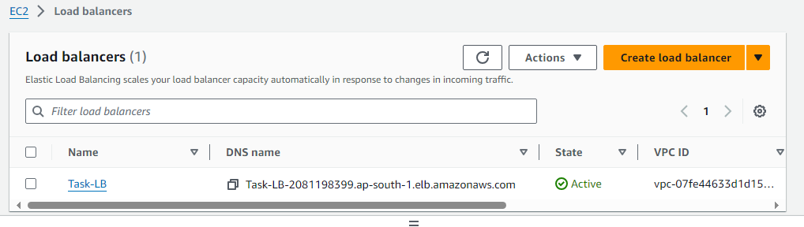

> **Launched two ec2-instances and connect it to a application load balancer, where the output traffic from the server must be an load balancer IP address**

